Sabera Tower
PRODUCTS
Renderoc RG
Nitofill EPLV
Lokfix, Nitobond EP, Rebol Emulsion Xtra
DTML SITE

Sabera Tower.
Gulshan, Dhaka, bANGLADESH.

Repair products

CLIENT : Sabera Tower.
coNSULTANT : BRTC, BUET.
CONTRACTOR : Nutech construction chemicals Company LTD.
Sector : commercial buildings

Year : 2014
CASE STUDY
Sabera tower is a 6 storied commercials building. Owing to sudden price hike and scarcity of commercial spaces, client raised the same to 8 storied from 6 storied with very poor quality of construction work. The same is identified by RAJUK and asked owner for immediate retrofitting though recognized company or demolished the same.
The Project
Since Fosroc got same sort of job done to Concord Center, a neighbouring tower though its associates, “ M/S Nutech construction Chemcials Co Ltd,. Owner of Sabera tower immediately contract Fosroc for the same. Since Fosroc or Nutech is not supposed to work as consulting house, Fosroc Involved BRTC to work as consultant.
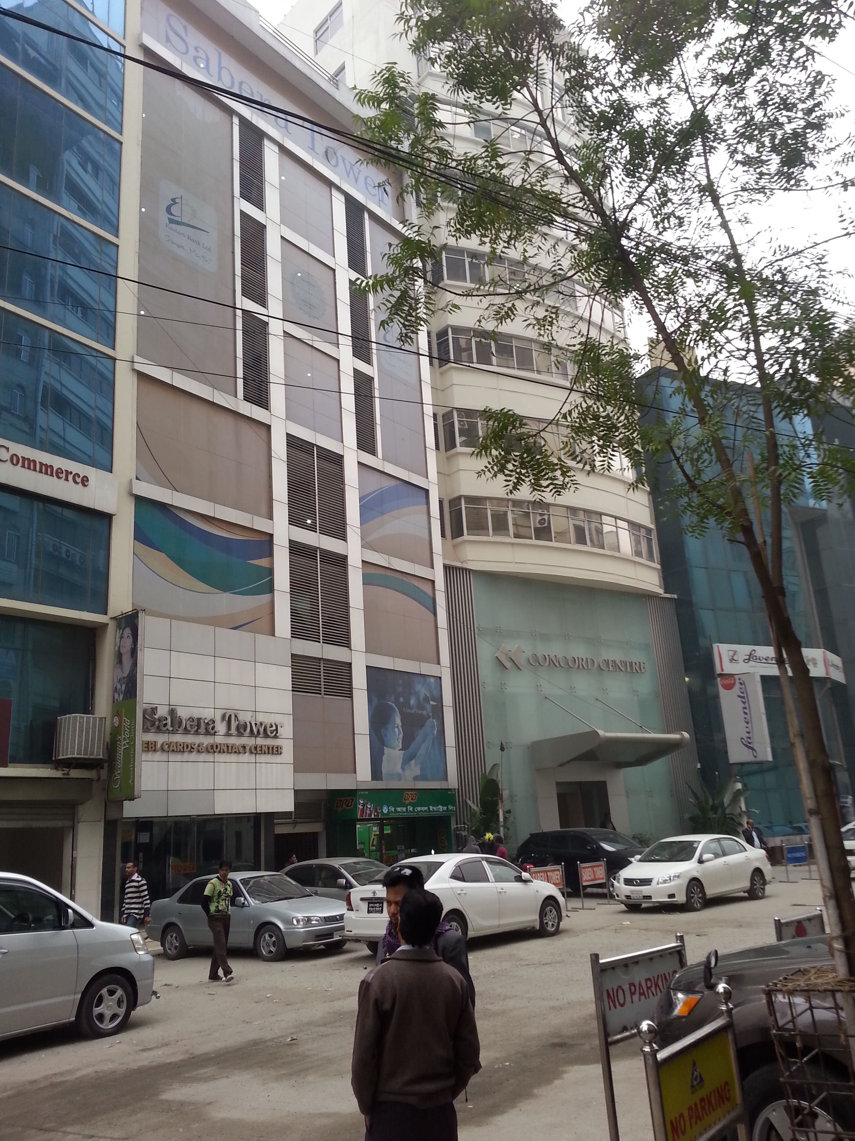
The Solution
Cracks on construction joint were filled by Fosroc Nitofill EPLV. Column was jacketed using Micro Concrete. Fosroc Nitobond EP, Lokfx, Cocure WB and Reebol Emulsion Xtra were used as supporting products.
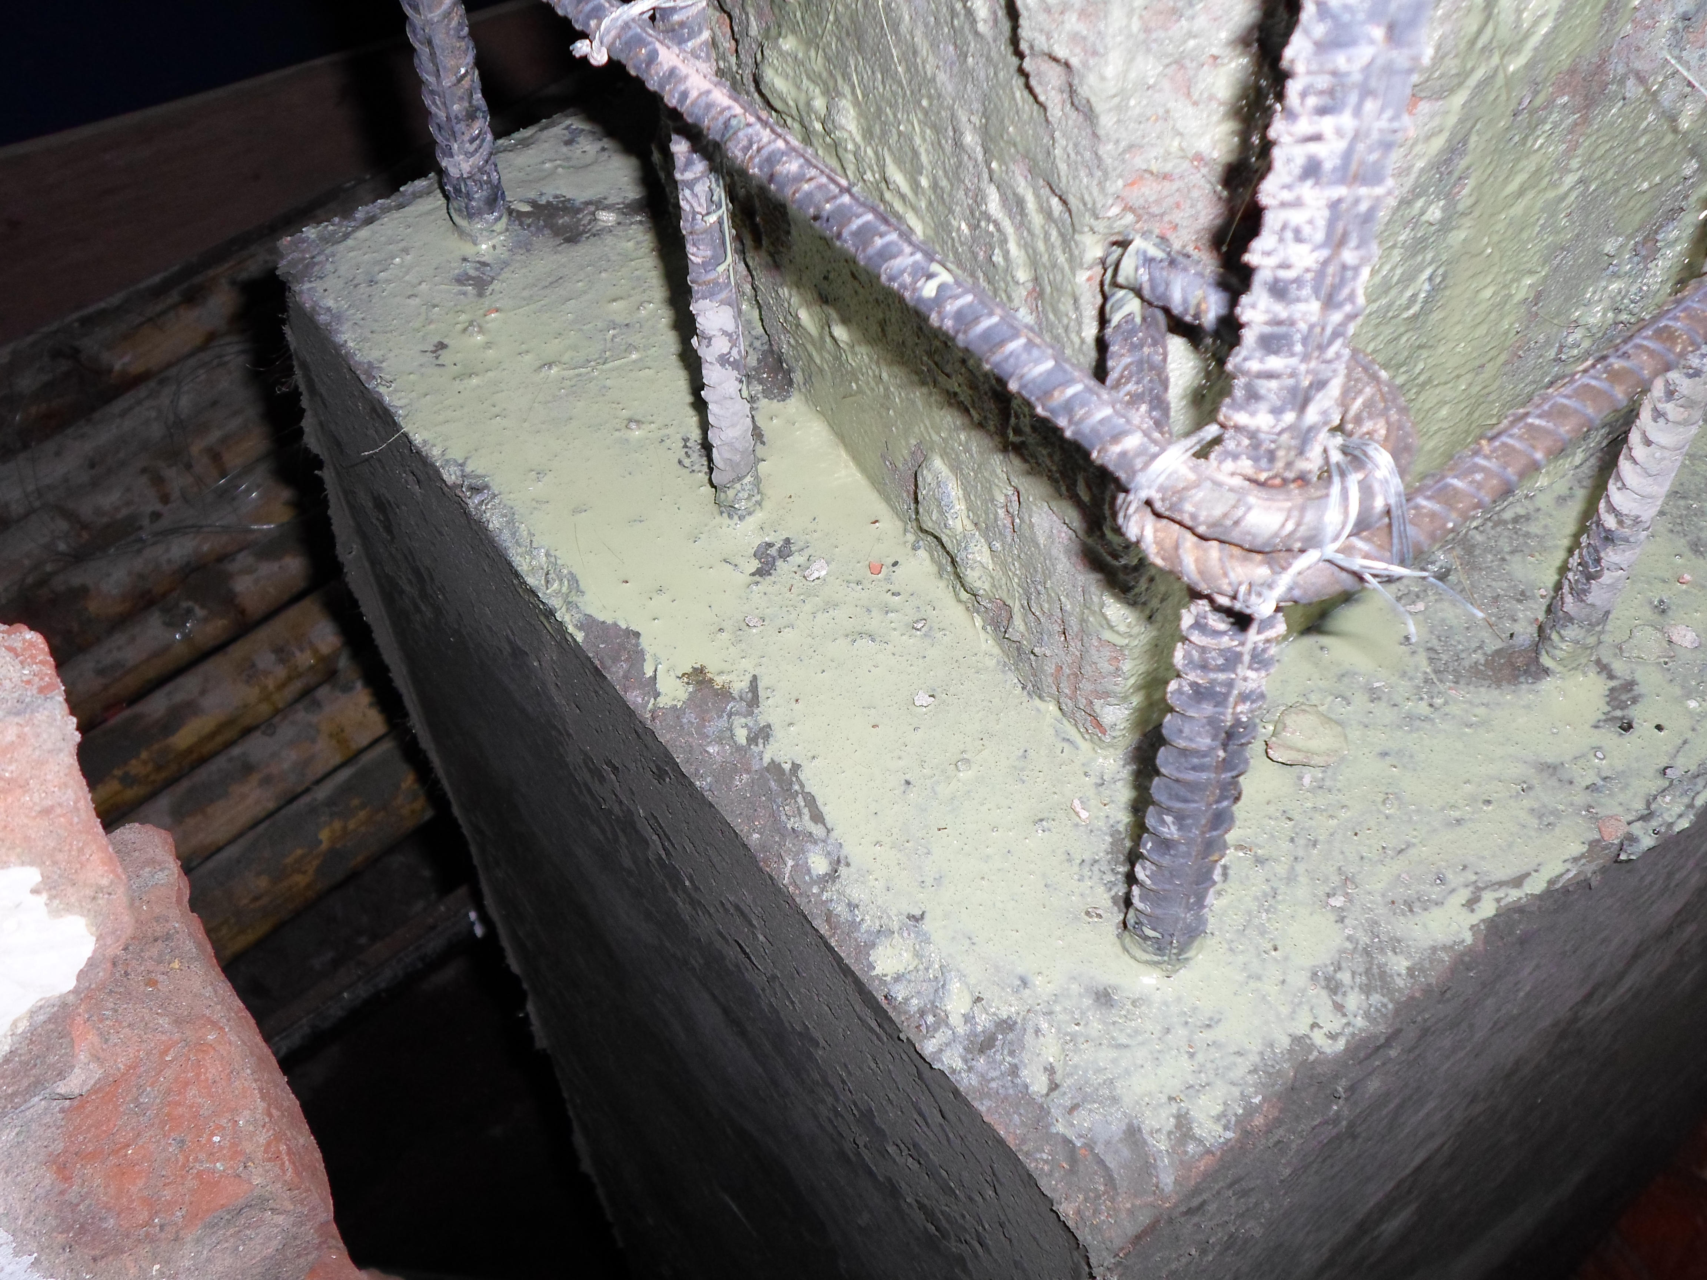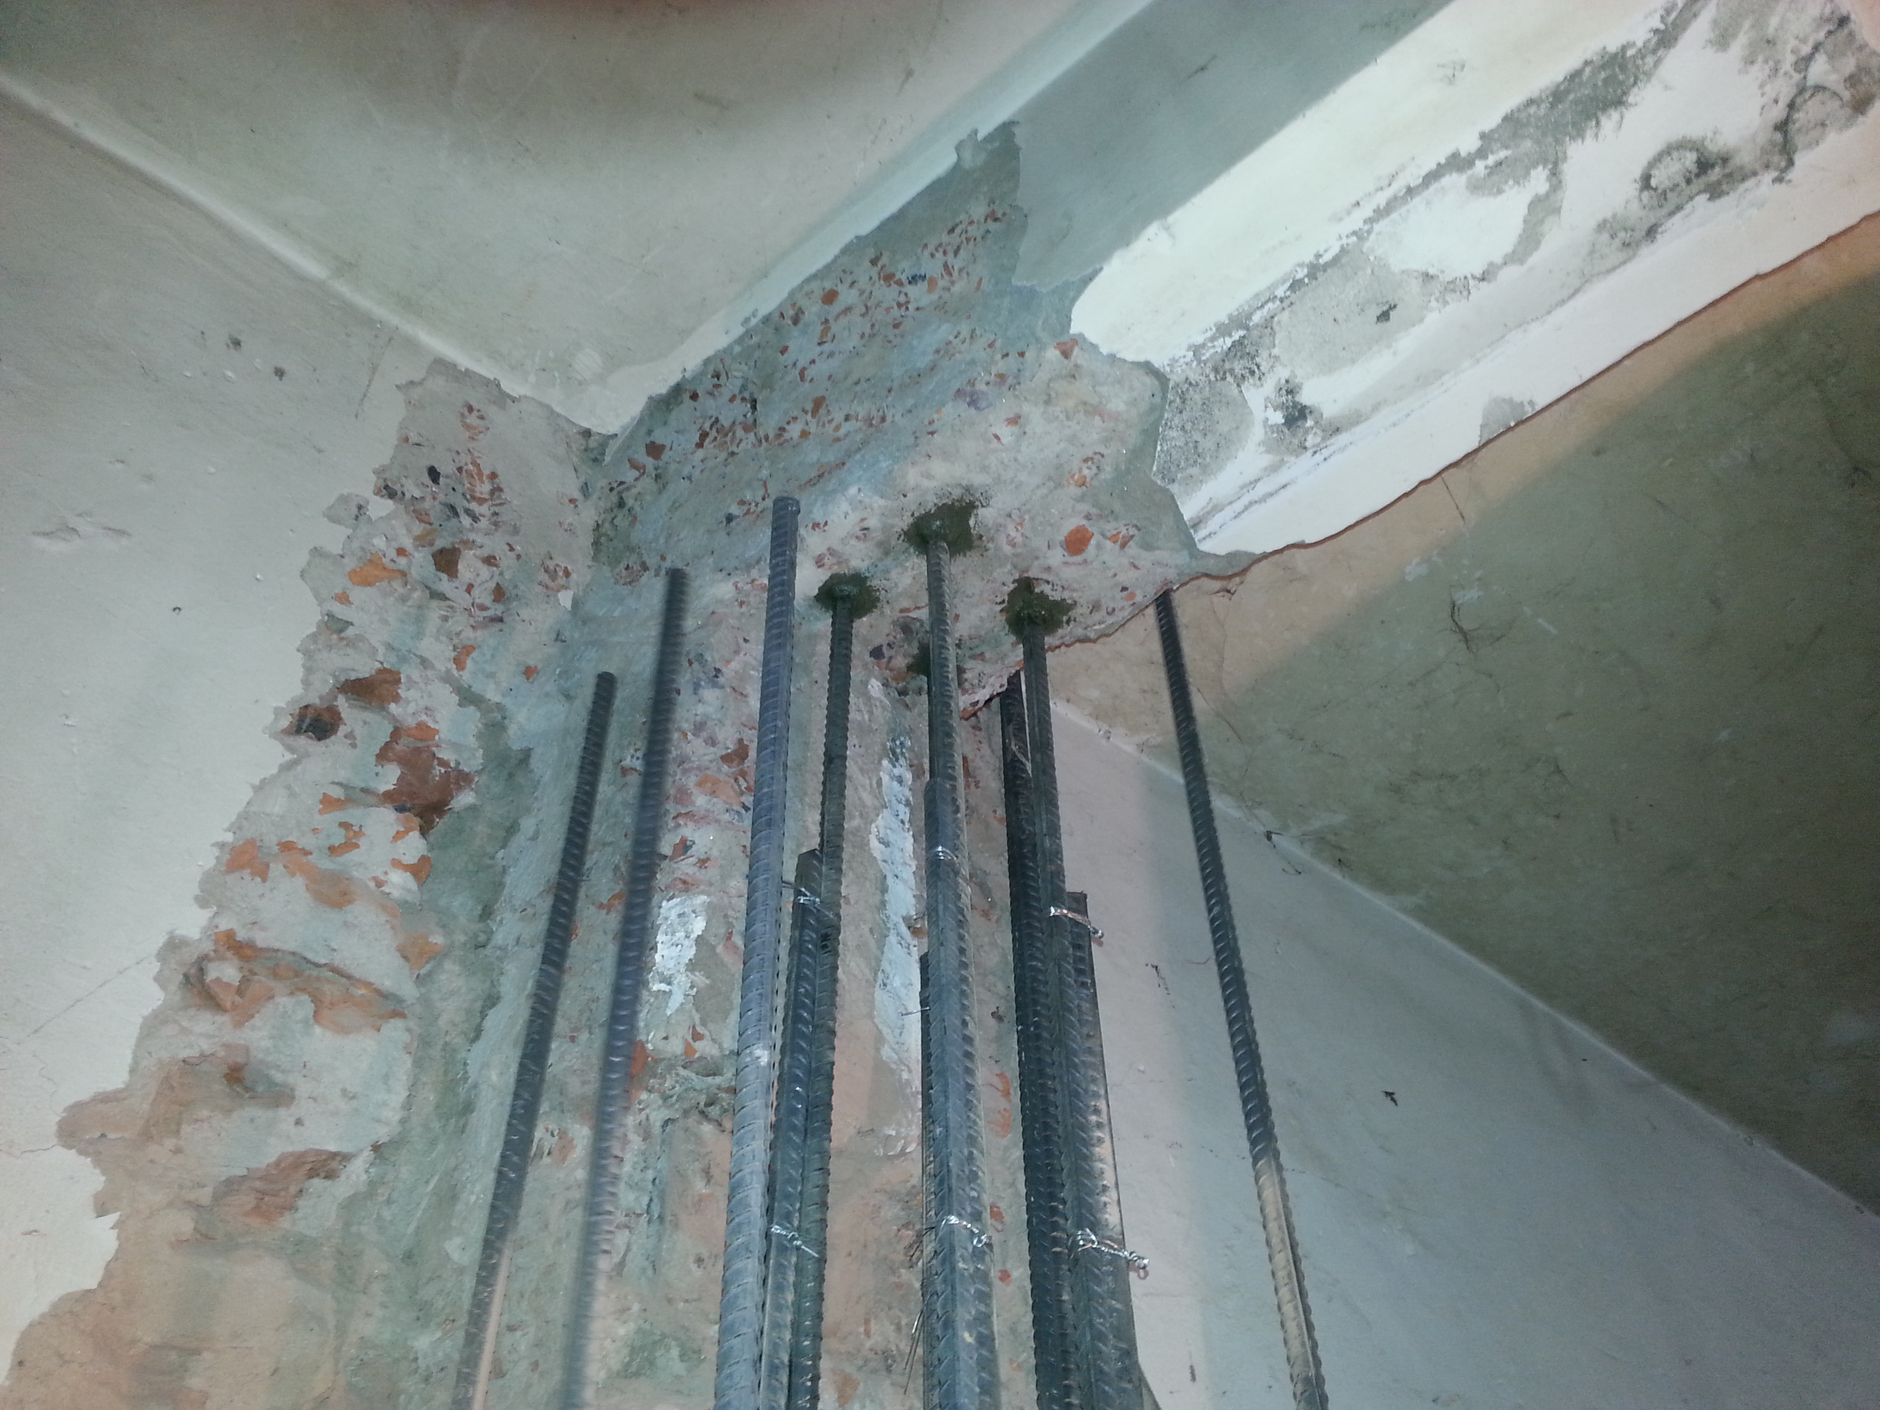

Sedimentation Tank after application

